## Quality Policy

Valvology is engaged in the business of valve integrity management via maintenance, repairs, testing, quality assurance, and the sale of the highest quality valve products. This policy applies to all of our core products and services throughout the organisation.

The purpose of this policy is to confirm our commitment to meeting the quality standards expected by our customers in the delivery of the products and/or services that we supply to them.

Our quality objectives for 2024 are to:

* Achieve ISO 9001 and ISO 45001 certification by March 2024.
* We will receive two individual feedback events from a minimum of five key clients by the end of 2023FY.
* Complete establishment of 95 Great Eastern Highway, Rivervale workshop to complete all testing capabilities within our scope of accreditation.
* Initiate a valve integrity management program with all valves inspected by Valvology.
* We will report openly on our QHSE statistics.
* We will develop and initiate a training program to ensure al personnel are provided the opportunity to achieve the skills required to be successful in their role within the business.

To implement this policy, we shall focus on the needs of our business with particular reference to consistently meeting our customers' requirements and statutory obligations. Our quality management system will provide mechanisms for detecting system shortfalls and for stimulating process improvements.

Valvology has developed procedures and disciplines to ensure that:

* The system is effectively implemented by undertaking relevant skills training and conducting appropriate quality awareness training;
* Responsibilities for quality are established by communicating these responsibilities clearly to all employees;
* The policy and procedures continue to be appropriate by initiating regular reviews to check its effectiveness and ongoing relevance, and the company regularly review the needs and expectations of our customers and initiate continuous improvement activities to meet these expectations.

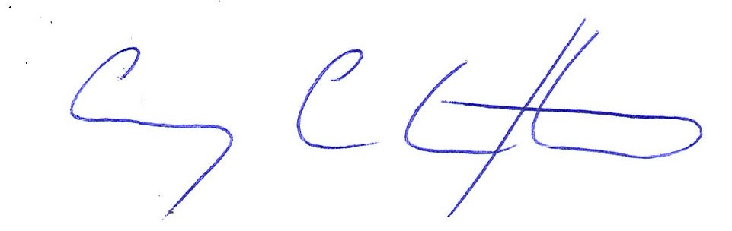

Corey Clifton

Director

16th January 2024